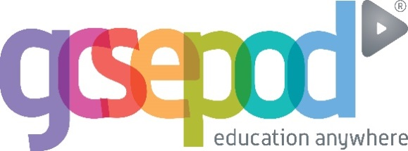

GCSEPod is now available at West Kirby Residential School! We have subscribed to the award-winning service to give your child access to thousands of hours of professionally produced, audio-visual content which will benefit them throughout the coming year.

GCSEPod has over 4,000 teacher-written, audio-visual pods which have been produced specifically for learning, homework and revision. The Pods contain all the right facts, quotes, keywords, dates and annotated diagrams that your child needs for GCSE success. They won’t need to use GCSEPod for long to see the impact; in fact, consistent use of just 10 minute chunks is proven to support achievement whatever your child’s target grade is.

The GCSEPod website can be viewed on mobiles, tablets and PCs and the Pods can be downloaded for offline viewing. The Pods are mapped to the curriculum and students can access pre-set exam playlists which collate all the Pods relevant to a specific exam into a neatly organised list.

Once your child has activated their account they can browse the Pod library and create their own playlists – just as they would when they’re listening to music. We recommend that you discuss GCSEPod with your son or daughter to ensure that they have successfully activated their accounts and encourage them to make use of this service throughout their GCSEs.

For more ways you can help support your child using GCSEPod, visit
www.gcsepod.com/parents
where you’ll find lots more information and resources.

